Standard Test Methods for
Determining the Performance of RFID Transponders on Unit Case Loads¹
This standard is issued under the fixed designation D XXXX; the number immediately following the designation indicates the year of original adoption or, in the case of revision, the year of last revision. A number in parentheses indicates the year of last reapproval. A superscript epsilon (ε) indicates an editorial change since the last revision or reapproval. This standard is being developed as part of a new task group chaired by Dr. Robb Clarke (clarker@msu.edu). Please provide any comments directly to task group chair.

1. Scope
1.1 These test methods determine the readability of RFID transponders placed on unit case loads that are manually handled or mechanically handled by material handling equipment such as fork trucks, pallet jacks, and automated guided vehicle systems. The results of these tests are intended to be used for qualitative purposes.
1.2 This test method is intended for use in laboratory settings that simulate, as closely as is practicable, the distribution environment of the product being tested.
1.3 The values stated in SI units are to be regarded as the standard. The values given in parentheses are provided for information only.
1.4 This standard does not purport to address all of the safety concerns, if any, associated with its use. It is the responsibility of the user of this standard to establish appropriate safety and health practices and determine the applicability of regulatory limitations prior to use.
2. Referenced Documents
2.1 ASTM Standards:
D 996 Standard Terminology of Packaging and Distribution Environments
E 337 Standard Test Method for Measuring Humidity with a Psychrometer (the Measurement of Wet- and Dry-Bulb Temperatures)
D 4332 Standard Practice for Conditioning Containers, Packages, or Packaging Components for Testing
3. Terminology
3.1 Definitions—Terms and definitions used in these test methods may be found in Terminology D 996.
3.2 Definition of Terms:
3.2.1 transponder acquisition distance- the distance between the transponder and the interrogator antenna at which a transponder is first detected by an RFID system, when moving the transponder into the read field.
3.2.2 critical transponder distance- the distance between the transponder and the interrogator antenna at which a transponder becomes undetectable by an RFID system, when moving the RFID transponder out of the read field.
3.2.3 read field- the area in which an RFID transponder is capable of responding to the interrogator. The outer most boundary of the read field correlates to the critical transponder distance. The distance between the critical transponder distance and the transponder acquisition distance represents an area of RF energy that may or may not be sufficient to activate a passive transponder.
3.2.4 RF inhibiting- a substance or material that causes a significant reduction in the effectiveness of radio waves that reach an RFID transponder
3.2.5 RF enhancing- a substance or material that, when in the presence of radio waves, creates constructive interference, causing the amplitude of the radio waves to increase. Ultimately, the resulting wave experiences an increase in intensity and power, and thus, the wave retains higher energy at a farther distance from the interrogator antenna.
3.2.5 RF transparent- a substance or material that has little or no significant impact on the performance of an RFID system
3.2.6 direct line of sight- an unobstructed visible path from one object to another
3.2.7 software- an array of logic, displayed as an application, used to access and control a device
3.2.8 firmware- a series of programmable instructions, stored in read only memory (ROM), which controls the capabilities of an interrogator
3.2.9 Radio Frequency Identification (RFID)- a wireless data communication technology that uses radio waves to transfer data from one source to another.
3.2.10 RF- the energy used by RFID systems to activate transponders and wirelessly transfer information.
4. Summary of Test Methods
4.1 Read field mapping- This method is used to determine the read performance of the RF system inclusive of the reader/antenna and transponder with a control case. The testing is conducted with the RFID transponder specimen moving both toward and away from the RFID antenna. The strength of signal and overall read field may vary from system to system and differ from location to location depending upon the various interferences.
4.2 Testing the product/package system- This method is used to determine the transponder readability in the established read field of the system while affixed to the product unit case load. The testing involves the product/package combination. The testing is conducted with the filled case of the product moving both toward and away from the RFID antenna.
5. Significance and Use
5.1 Many materials used in the production of goods can have an adverse affect on the performance of an RFID system. This test method qualifies the performance of an RFID system applied to a unit case load relative to the performance of the same RFID system applied to an empty case. Comparison of these two elements of this test method will identify the compatibility of the RFID systems and the product being tested.
6. Interferences
6.1 RFID systems are subject to interference from metal, water and ambient RF energy. If significant levels of any of these interferences are present in the immediate testing area, the observed read field will be affected. Due to uncontrolled variation in testing facilities, numerical values for interference cannot be stated. Possible sources of interference shall be documented in the final report.
6.1.1 Documentation of interference shall include information regarding, material, size and location relative to interrogator antenna.
6.2 If significant levels of interference are unavoidable, testing shall be conducted in such a manner that interferences remain unchanged throughout testing.
7. Atmospheric Conditions
7.1 Testing shall be conducted at Standard Conditioning Atmosphere- 23 +/- 1°C (73.4 +/- 2°F) and 50 +/- 2 % relative humidity.
7.2 The exact measurement of temperature and relative humidity of the testing atmosphere shall be made as close to the specimen being exposed as is possible. (See Test Method E 337 for a detailed description of methods.) The temperature and relative humidity indicated at the control point may not be representative of conditions elsewhere in the conditioned space due to local effects or deficiency in air circulation. Tolerances at the controller usually must be smaller than those at the specimen.
8. Apparatus
8.1 Case Stand- The case stand shall be constructed of an RF neutral material (wood or plastic, ideally) that can support the weight of the full case unit load, allow for case height adjustment and allow for controlled movement along the radian being tested.
8.2 Antenna Stand- The antenna stand shall be a stationary support constructed of an RF neutral material (wood or plastic, ideally) that can support the weight of the antenna being used while allowing for antenna height adjustment.
8.2.1 Protractor- A large protractor shall be placed at the base of the antenna stand to visually guide the operator along the radian being tested.
8.3 RFID System:
8.3.1 Interrogator- A manufactured device that communicates with RFID transponders via antennae, and communicated transponder information to the host computer.
8.3.2 Interrogator Antenna- A manufactured device that emits RF energy to transponders and receives information from transponders in the form of reflected RF energy.
8.3.3 Transponder- A microchip with a small conductive antenna that receives RF energy from the interrogator antenna and reflects the information on the micro chip back to the interrogator antenna in the form of RF energy.
8.3.4 Host Computer- Any computer with the proper software to communicate with and operate the RFID interrogator.
8.4 Unit Case Load- The unit case load shall consist of the assembled packaging system, to include the product as well as the primary secondary and/or tertiary packaging up through the shipping case level.
8.5 Control Case- The shipping case of the unit case load, excluding the product as well as the primary, secondary and/or tertiary packaging shall be considered the control case.
9. Test Specimen
9.1 A case unit load test specimen shall consist of a case unit load representative of a production run package, or components of an assembled packaging system, to include primary secondary and/or tertiary packaging up through the shipping case level.
9.2 An RFID transponder specimen shall be a randomly selected transponder from an RFID transponder inventory.
10. Conditioning
10.1 Test specimens shall be conditioned at the standard conditioning atmosphere of 23 ± 2°C (73.4 ± 3.6°F) for a minimum of 24 h prior to testing (see Practice D 4332)
11. Procedure
11.1 Mapping the read field
11.1.1 Determining the critical distance read field of the control case
11.1.1.1 Assemble RFID system.
11.1.1.2 Affix RFID transponder to the control case.
11.1.1.2.1 The location of the transponder on the control case shall be documented and held constant throughout testing.
NOTE 1- Transponder placement was observed to be an important variable affecting the readability of the transponder affixed to the product/package system.
11.1.1.3 Mount the interrogator antenna to the antenna stand. Record the distance from the floor to the center of the interrogator antenna.
11.1.1.4 Place the control case on the case stand such that a direct line of sight exists between the interrogator antenna and the transponder.
11.1.1.4.1 Adjust the height of the case stand such that the distance from the floor to the center of the transponder is equal to the height recorded in 11.1.1.3.
11.1.1.5 Place the case stand along the +90 degree radian, as close to the antenna stand as possible.
11.1.1.6 Slowly, move the case stand along the radian, away from the interrogator antenna, at a consistent speed until the RFID system no longer detects the transponder.
NOTE 2- Transponder detection is usually indicated by the graphical user interface on the host computer screen.
11.1.1.7 Record the critical transponder distance.
11.1.1.8 Repeat steps 11.1.1.5 through 11.1.1.7 for all radii in the in the +/- 90 degree spectrum at increments of 15 degrees.
NOTE 3- Testing may also be done at increments of less than 15 degrees depending upon the level of precision desired.
11.1.2 Determining the transponder acquisition read field of the control case.
11.1.2.1 Place the case stand along the +90 degree radian at a distance that exceeds the corresponding critical transponder distance by 5 feet.
11.1.2.2 Slowly, move the case stand along the radian, toward the interrogator antenna, at a consistent speed (equal to the speed used in 11.1.1.6) until the RFID system first detects the transponder.
11.1.2.3 Record the transponder acquisition distance.
11.1.2.4 Repeat steps 11.1.2.1 through 11.1.2.3 for all radii in the in the +/- 90 degree spectrum at increments of 15 degrees.
11.1.3 Determining the critical distance read field of the unit case load
11.1.3.1 Assemble the unit case load to include the product as well as the primary secondary and/or tertiary packaging, using the control case as the shipping case.
11.1.3.2 Place the case stand along the +90 degree radian, as close to the antenna stand as possible.
11.1.3.3 Slowly, move the case stand along the radian, away from the interrogator antenna, at a consistent speed (equal to the speed used in 11.1.1.6) until the RFID system no longer detects the transponder.
11.1.3.4 Record the critical transponder distance.
11.1.3.5 Repeat steps 11.1.3.2 through 11.1.3.4 for all radii in the in the +/- 90 degree spectrum at increments of 15 degrees.
11.1.4 Determining the transponder acquisition read field of the unit case load.
11.1.4.1 Place the case stand at a distance that exceeds the critical transponder distance by 5 feet.
11.1.4.2 Slowly, move the case stand along the radian, toward the interrogator antenna, at a consistent speed (equal to the speed used in 11.1.1.6) until the RFID system first detects the transponder.
11.1.4.3 Record the transponder acquisition distance.
11.1.4.4 Repeat steps 11.1.4.1 through 11.1.4.3 for all radii in the in the +/- 90 degree spectrum at increments of 15 degrees.
11.2 Mapping the read field envelope.
NOTE 4- Read field envelope testing is an optional portion of this test method, not required for compliance with this test standard.
11.2.1 Perform all steps outlined in mapping the read field (11.1), except 11.1.1.4.1, beginning with the center of the transponder at a height of one foot from the floor.
NOTE 5- If the transponder location does not allow the transponder to be adjusted to this height, begin testing at two feet and note this change in the final report.
11.2.2 Raise the height of the case stand by an additional one foot and again repeat all steps outlined in mapping the read field, except 11.1.1.4.1.
11.2.3 Repeat step 11.2.2 until the height from the floor to the center of the transponder is six feet.
12. Interpretation of Results
12.1 Graphical Representation
12.1.1 The acquisition distance and the critical distance for both a control case and a unit case load should be graphically displayed in separate scaled diagrams representing the +/- 90 degrees quadrant around the interrogator antenna (Fig. 1).
NOTE 6- Additional composite graphs may be produced to include acquisition and critical distances on the same diagram (Fig. 2) or 3D images if read field envelope testing is performed (Fig. 3).

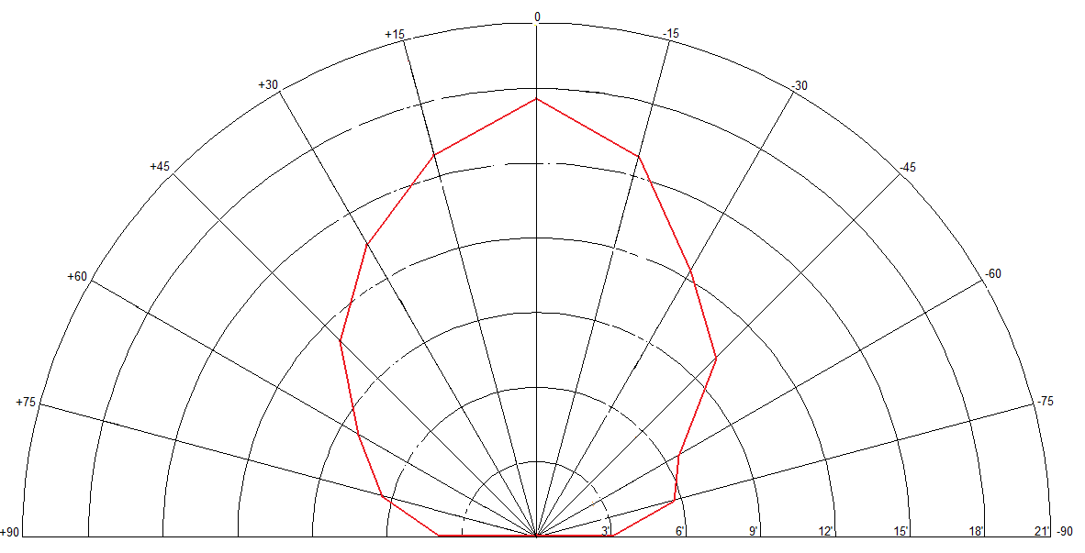
FIG. 1 Example of an Individual Graphical Representation
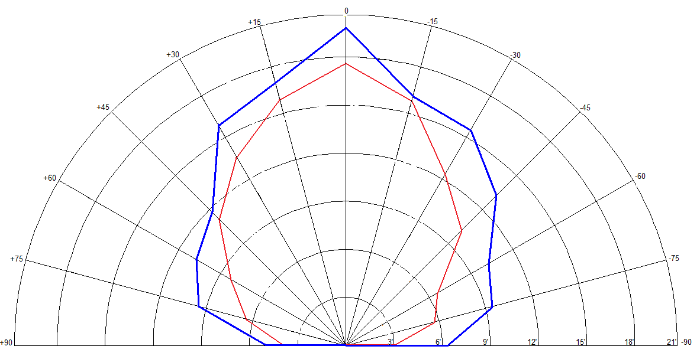
FIG. 2 Example of a Composite Graphical Representation

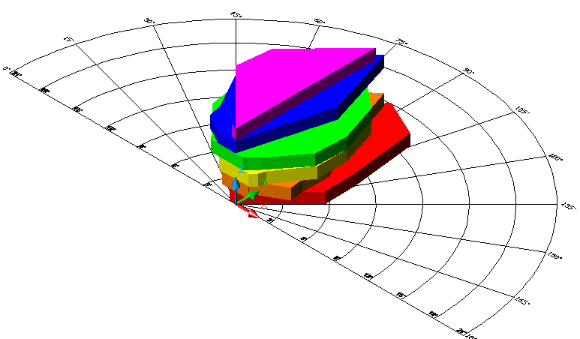
FIG. 2 Example of a 3D Read Field Envelope Graphical Representation

12.2 Comparative Analysis
12.2.2 If the RFID transponder is not detected when affixed to the unit case load, the unit case load is considered to have RF inhibiting characteristics
12.2.3 If the RFID transponder is detected at greater distances than when affixed to the control case, the unit case load is considered to have RF enhancing characteristics
12.2.4 If the RFID transponder is detected at equivalent distances than when affixed to the control case, the unit case load is considered RF transparent
13. Report
13.1 Report the following information:
13.1.1 A statement that the test was conducted in compliance with these test methods or a description of any deviation(s) from these test methods.
13.1.2 Identification of the RFID system including:
13.1.2.1 Identification of the make, model and firmware version of the interrogator.
13.1.2.2 Identification of the make and model of the interrogator antenna
13.1.2.3 Identification of the make and model of the transponder
13.1.2.4 Identification of the make, model and software version (where applicable) of the host computer
13.1.3 Description of the product, internal packaging, shipping container and closure system, where applicable.
13.1.4 The temperature and humidity conditioning prior to testing.
13.1.5 Graphical representations of the observed read fields (individual or composite) including:
13.1.5.1 Critical transponder distance for the control case
13.1.5.2 Transponder acquisition distance for the control case
13.1.5.3 Critical transponder distance for the unit case load
13.1.5.4 Transponder acquisition distance for the unit case load
13.1.5.5 Read field envelope, if applicable.
14. Precision and Bias
14.1 Due to the qualitative nature of this test method, no statement is made about either the precision or bias of the resulting test data.
15. Keywords
15.1 radio frequency identification; RFID; packaging; read field; mapping; transponder; transponder acquisition distance; critical transponder distance

These test methods are under the jurisdiction of ASTM Committee D10 on Packaging and is the direct responsibility of Subcommittee D10.18 on Miscellaneous Packaging.

